

“Python Programming”

Assignment-1

Topic – Building a Calorie Tracking Console App

Submitted by – Tiya Mishra
Roll no - 2501730026
Course – B. Tech CSE (AI & ML)
Section – B
Faculty name- Mr Sameer Farooq

Introduction
The purpose of this lab assignment was to develop a quick and simple method for monitoring daily calorie intake. This mini-project aims to help students build a Python-based CLI (Command-Line Interface) tool where they can log their meals, track total calories consumed, compare against their personal daily limit, and save session logs for future tracking.

Objectives
- To practice Python basics such as variables, data types, and operators.
- To collect and store multiple inputs using lists.
- To perform arithmetic operations like summing and averaging.
- To use conditional statements to compare values.
- To display data in a structured tabular format.
- To implement file handling for generating a text-based report.
- To use the datetime module to timestamp the report.

Program Description
The program developed (tracker.py) is a Daily Calorie Tracking Console App. It prompts the user for inputs, stores meal information, calculates calories, displays a summary table, and optionally saves the report to a file.

Program Code
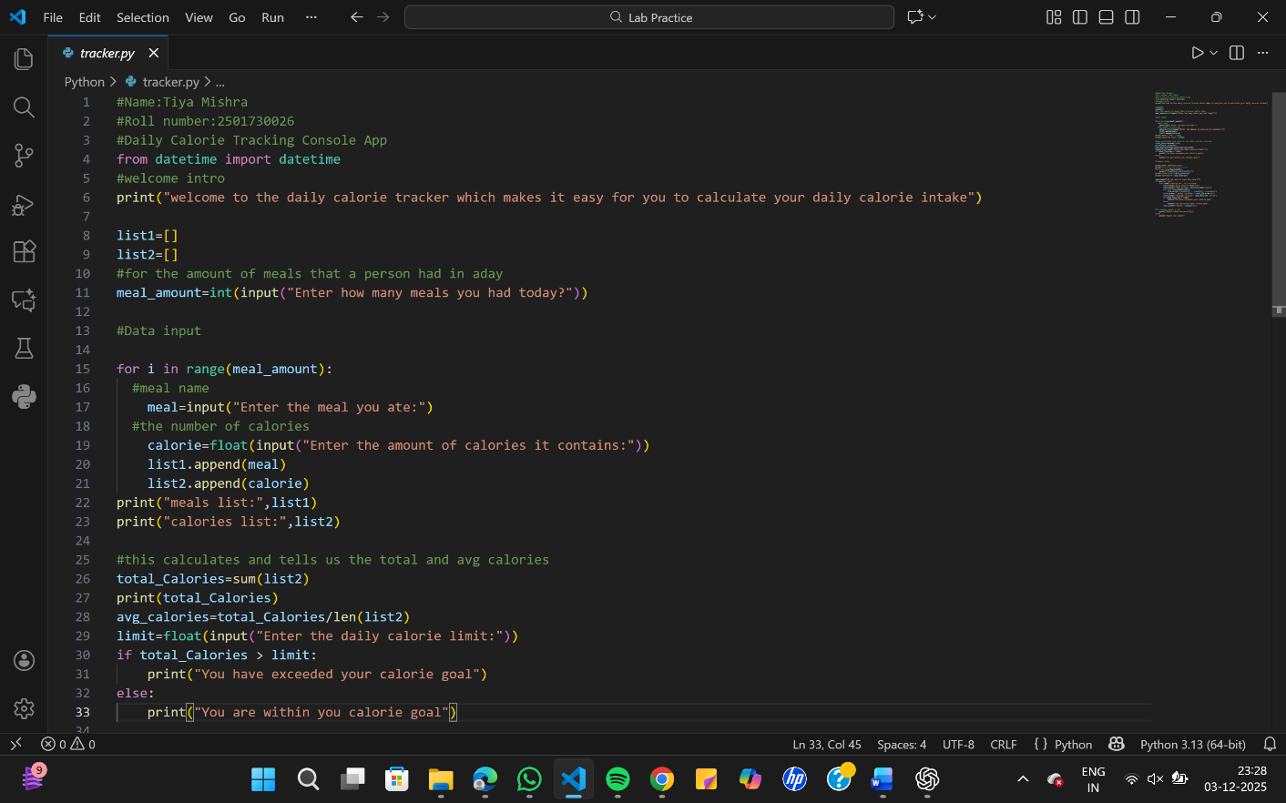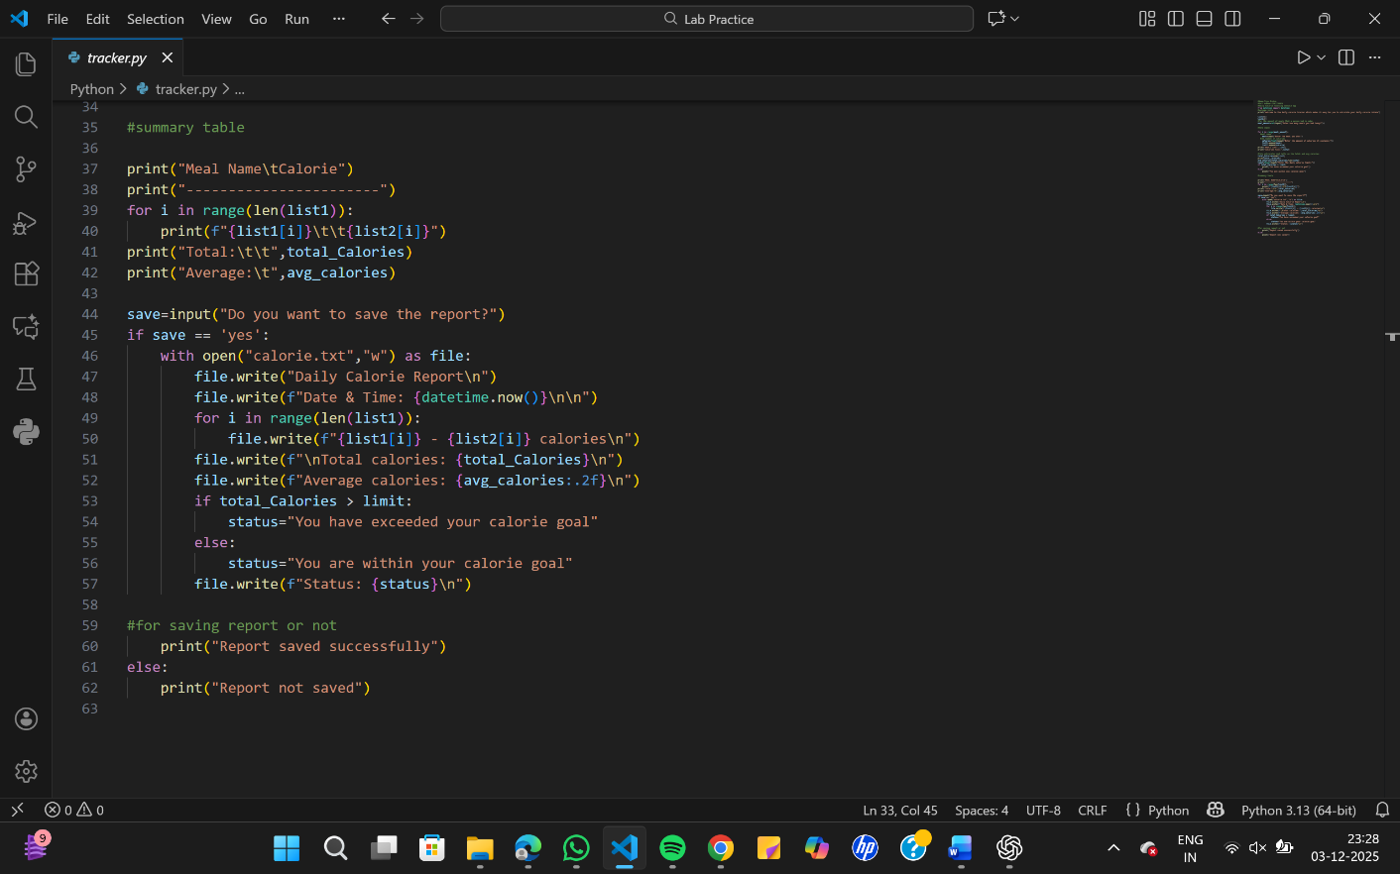

Sample Output
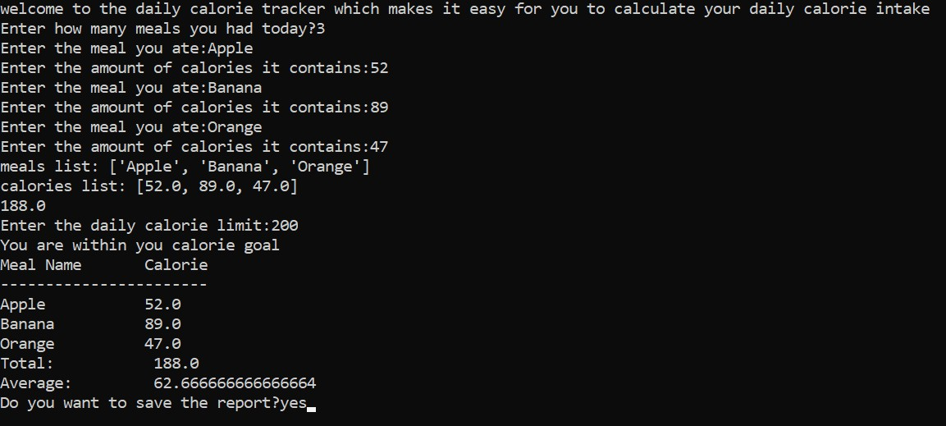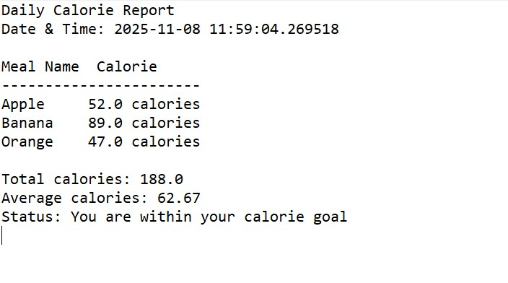

Conclusion
This assignment successfully demonstrates the use of Python fundamentals, including lists, loops, conditionals, arithmetic operations, formatted output, and file handling.

